Data Structures (2028C) --Fall 2019 **Lab 8 (week of 11/5-7/19)**

Topics covered***: Binary Trees***

*Lab due:* ***11:55PM on the day before the next lab***

Task: Create a printing trees function.

Write a recursive member function **outputTree** to display a **binary tree** object on the screen.

The function should output the tree row-by-row with the top of the tree at the left of the screen and the bottom of the tree toward the right of the screen. Each row is output vertically.

For example, the binary tree illustrated below is output as follows:

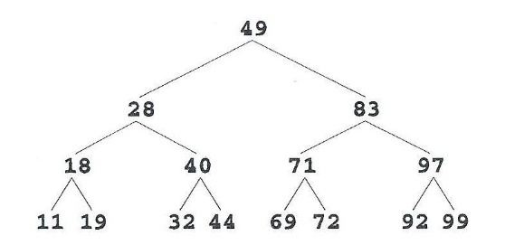

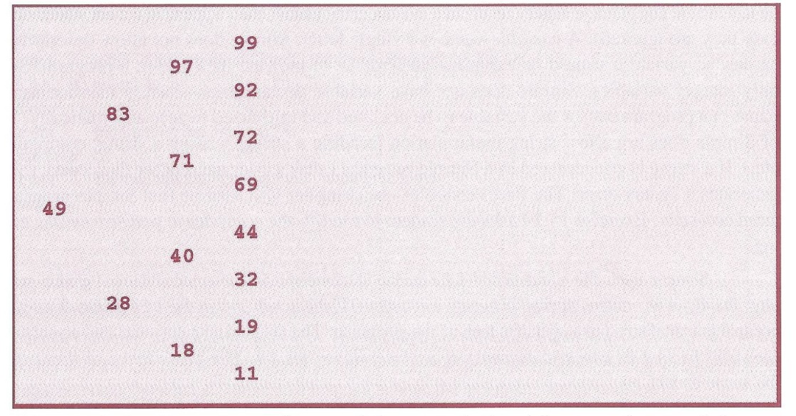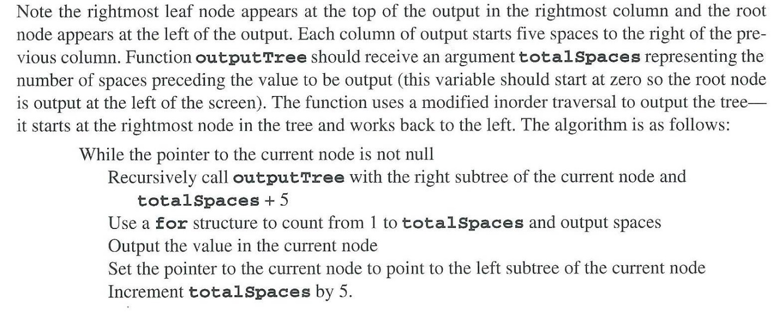

**Lab Submission:**

1. Write a lab report including the following information:

A description of the objectives/concepts explored in this assignment including why you think they are important to this course and a career in CS and/or Engineering.

1. Include all source code, input and output files (if any), and any special instructions to compile and run those programs.
2. Package all files in a single zip folder and submit the file to BlackBoard.

**Lab Grading:**

1. 20% - Lab attendance
2. 80% - Lab report contains all required information and is well written.

If program fails to compile, 0% will be given for that Task.